**HTML AND CSS**

**<button></button>**

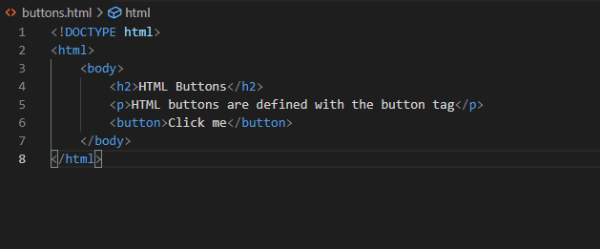

Output:

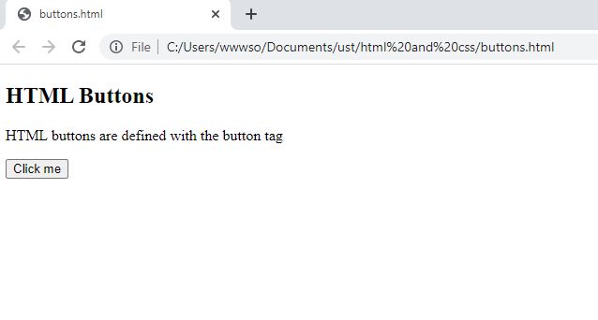

**<img >**

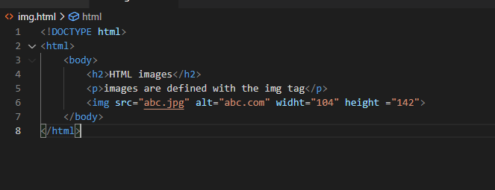

Output:

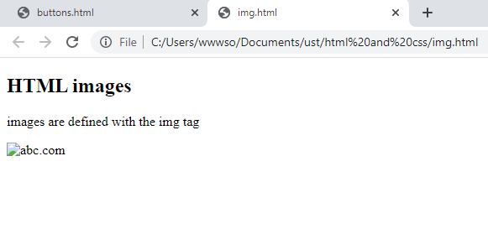

**alt :** This attribute is used to set an alternate tag so that the value provided in the alt is displayed if the image is not reloaded or not available.

**Height and width attributes:** The height and width attributes of the image tag defines the width and height of the image

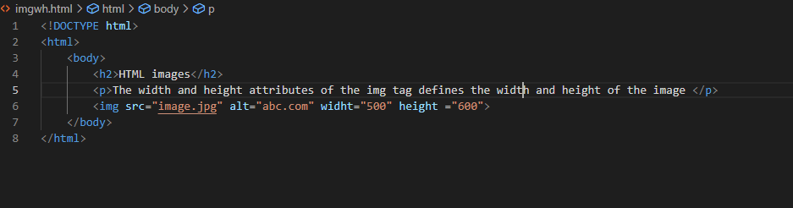

Output:

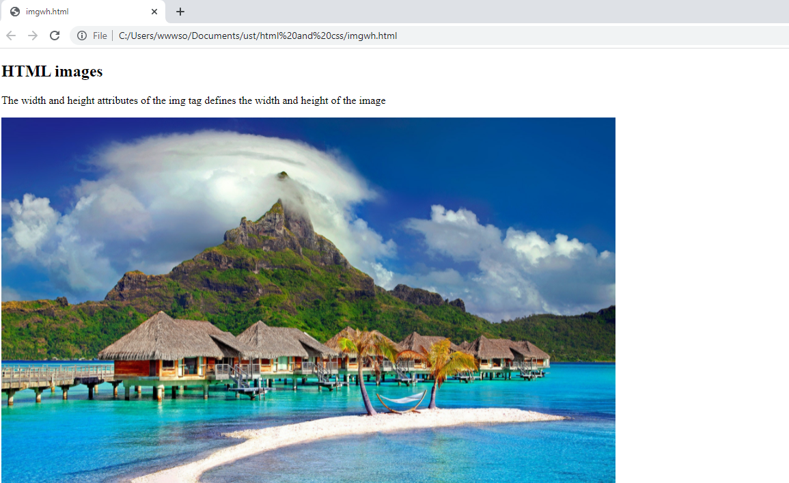

**<ol></ol> and <ul></ul>**

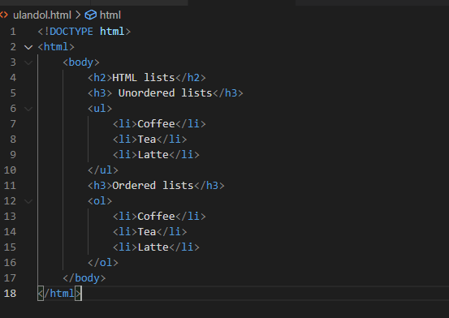

Output:

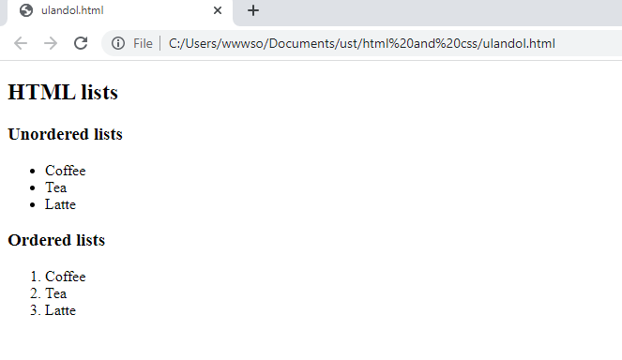

**Ordered lists with letters**

<!DOCTYPE html>

<html>

    <body>

        <h2>HTML lists</h2>

        <h3>Ordered lists with letters</h3>

        <ol type="A">

            <li>Coffee</li>

            <li>Tea</li>

            <li>Latte</li>

        </ol>

    </body>

</html>

Output:

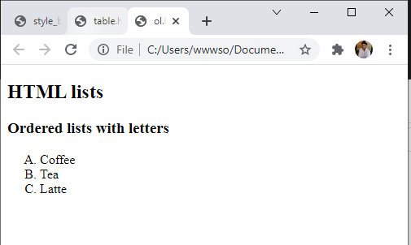

**<br><br>**

The text written inside the br tags is displayed in a new line

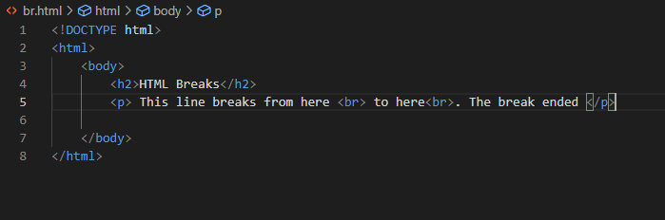

Output:

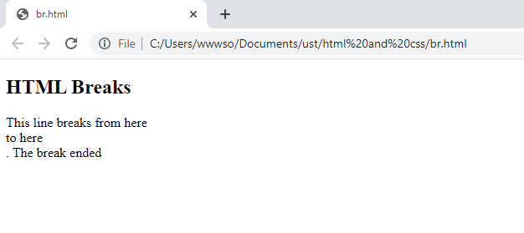

**<del></del>**

This strikes the text inside the tags

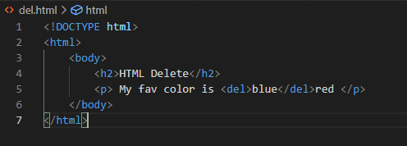

Output:

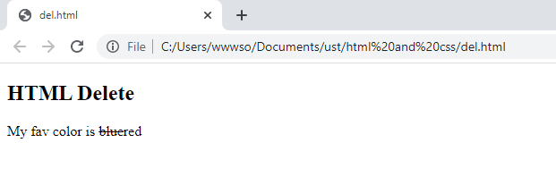

**<ins></ins>**

This inserts a text

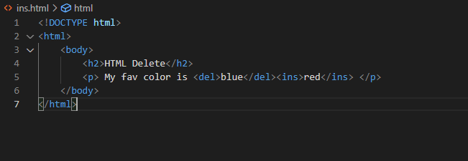

Output:

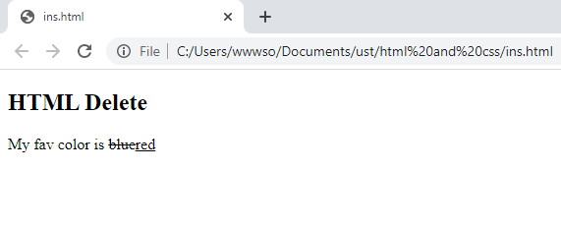

**<style></style>**

**Style :color**

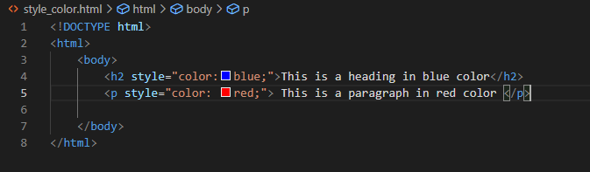

Output:

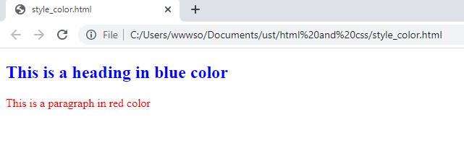

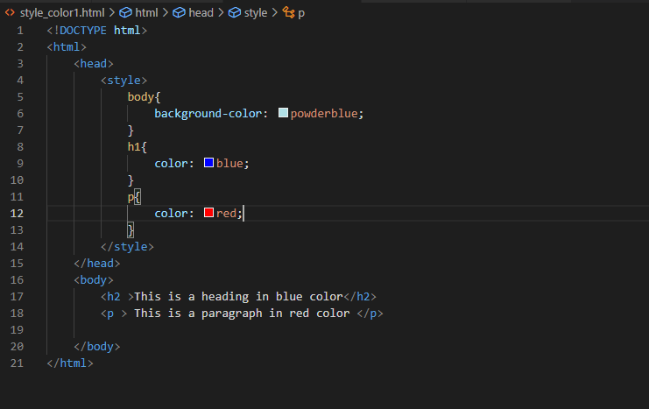

Output:

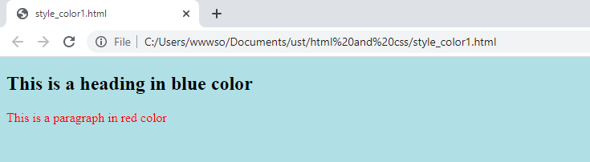

**Style:border**

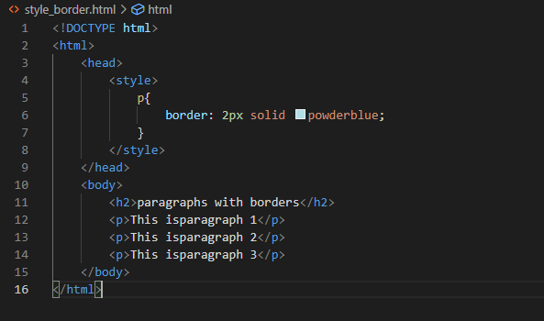

Output:

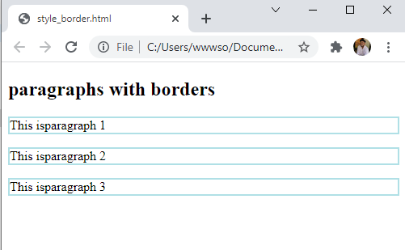

**<tables></tables>**

<!DOCTYPE html>

<html>

    <head>

        <style>

            table,tr,td {

                border: 1px solid white;

                border-collapse: collapse;

            }

            tr,td{

                padding: 5px;

            }

            td{

                background-color: powderblue;

            }

        </style>

    </head>

    <body>

        <table>

            <tr>

                <td>

                    <p>This is paragraph 1</p>

                    <p>This is paragraph 2</p>

                </td>

                <td>

                    This cell contains a table:

                    <table>

                        <tr>

                            <td>A</td>

                            <td>A</td>

                        </tr>

                        <tr>

                            <td>C</td>

                            <td>D</td>

                        </tr>

                    </table>

                </td>

            </tr>

            <tr>

                <td>

                    This cell contains a list:

                    <ul>

                        <li>Apples</li>

                        <li>Bananas</li>

                        <li>Mangos</li>

                    </ul>

                </td>

                <td>

                    Hello

                </td>

            </tr>

        </table>

    </body>

</html>

**Output:**

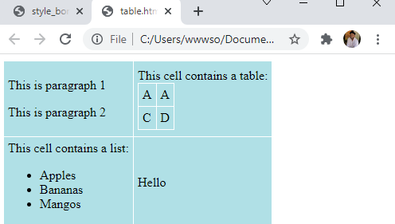

**<div></div>**

<!DOCTYPE html>

<html>

    <body>

        <div style="background-color: black;color: white;padding: 20px;">

        <h2>London</h2>

        <p>London is the capital city of England. It is the most populous city in the United Kingdom,

             with a metropolitan area of over 13 million inhabitants.</p>

        <p>Standing on the River Thames, London has been a major settlement for two millennia,

             its history going back to its founding by the Romans, who named it Londinium.</p>

        </div>

    </body>

</html>

Output:

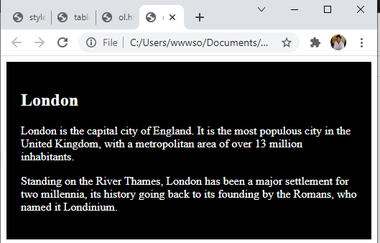

**<iframes></iframes>**

<!DOCTYPE html>

<html>

    <body>

        <h2>HTML iframes</h2>

        <p>An iframe is used to display a webpage within a webpage</p>

        <iframe src="div.html"></iframe>

    </body>

</html>

Output:

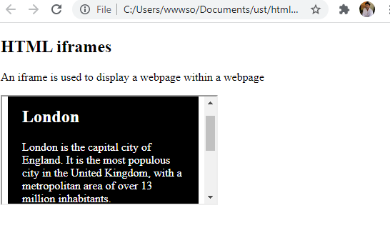

**<form></form>**

<!DOCTYPE html>

<html>

    <body>

        <h2>HTML forms</h2>

        <form action="/action_page.php">

        <label for="fname">First name:</label><br>

        <input type="text" id="fname" name="fnme" value="John"><br>

        <label for="lname">Last name:</label><br>

        <input type="text" id="lname" name="lname" value="Doe"><br><br>

        <input type="submit" value="Submit">

        </form>

        <p>If you click the "Submit" button,

             the form-data will be sent to a page called "/action_page.php".</p>

    </body>

</html>

Output:

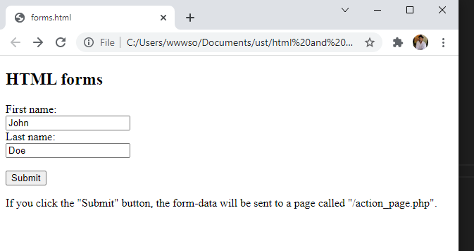

**Forms:date**

<!DOCTYPE html>

<html>

    <body>

        <h2>HTML forms</h2>

        <form action="/action_page.php">

        <label for="birthday">Date of birth:</label><br>

        <input type="date" id="birthday" name="birthday"><br>

        <input type="submit" value="Submit">

        </form>

        <p><strong>Note:</strong> type="date" is not supported in Internet Explorer 11 or prior Safari 14.1</p>

    </body>

</html>

Output:

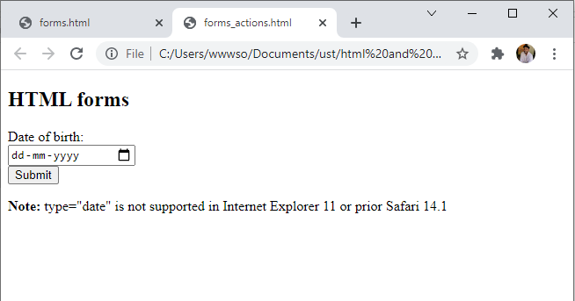

**Form:checkboxes**

<!DOCTYPE html>

<html>

    <body>

        <h2>HTML Checkboxes</h2>

        <form action="/action_page.php">

        <input type="checkbox" id="vehicle1" name="vehicle1" value="bike">

        <label for="vehicle1">I have a bike</label><br>

        <input type="checkbox" id="vehicle2" name="vehicle2" value="Car">

        <label for="vehicle2"> I have a car</label><br>

        <input type="checkbox" id="vehicle3" name="vehicle3" value="Boat">

        <label for="vehicle3"> I have a boat</label><br><br>

        <input type="submit" value="Submit">

        </form>

    </body>

</html>

Output:

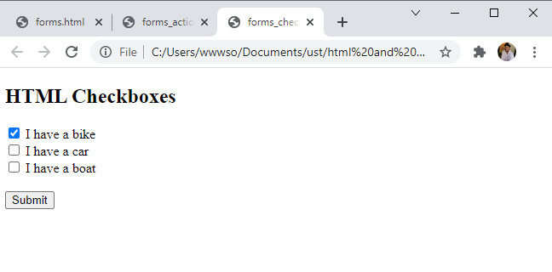

**<script></script>**

<!DOCTYPE html>

<html>

    <body>

        <h2>My first webpage</h2>

        <p>my first paragraph</p>

        <p>Never call document.write after the document has finished loading.

            It will overwrite the whole document.</p>

        <script>

            document.write(5+6);

        </script>

    </body>

</html>

Output:

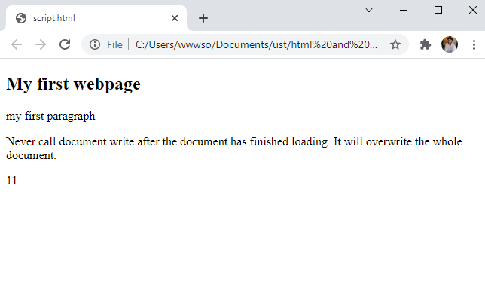

**Javascript expressions:**

<!DOCTYPE html>

<html>

    <body>

        <h2>Javascript Expressions</h2>

        <p>Expressions compute to values</p>

        <p id="demo"></p>

        <script>

            document.getElementById("demo").innerHTML=5*10

        </script>

    </body>

</html>

Output:

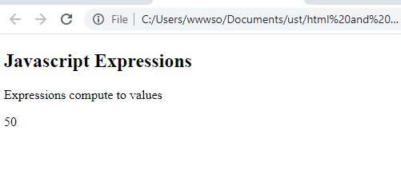

**Java functions:**

<!DOCTYPE html>

<html>

    <body>

        <h2>Javascript Functions</h2>

        <p>This example calls a function which performs a calculation and returns the result:</p>

        <p id="demo"></p>

        <script>

            var x = myFunction(4,3);

            document.getElementById("demo").innerHTML=x;

            function myFunction(a,b){

                return a*b;

            };

        </script>

    </body>

</html>

Output:

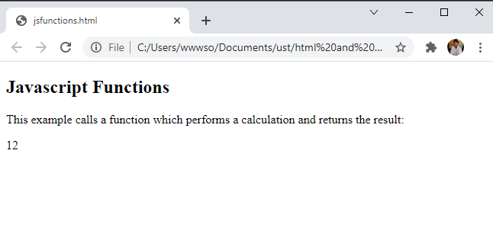

**String methods:**

<!DOCTYPE html>

<html>

    <body>

        <h2>Javascript String methods</h2>

        <p>Display the first array element, after a string split:</p>

        <p id="demo"></p>

        <script>

            let text = "a,b,c,d";

            const arr= text.split(",");

            document.getElementById("demo").innerHTML=arr[0];

        </script>

    </body>

</html>

Output:

